Assignment for “A Parent’s Story” webinar

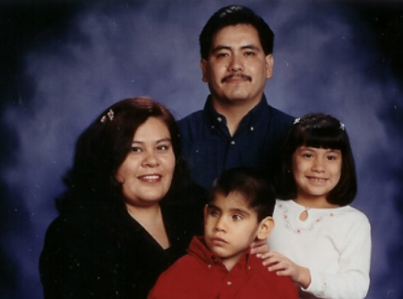

Every family has an important story. In this 60-minute presentation, Myrna Medina, Family Engagement Specialist at California Deafblind Services and mother to a son, Norman, with deaf-blindness, tells her family's story, including:

Their experiences as they encountered situations common to all families of children with special needs

Their interactions with service systems (early intervention, school, transition) at different stages of Norman's life

Grief and other emotions they experienced and how they coped

In this video you will learn:

The importance of remembering that behind the day-to-day details of schools and services every family has a personal story

Strategies for supporting families

Please watch the webinar (https://nationaldb.org/library/page/2694) and write a two-page paper on:

Tips and strategies that Myrna suggests for providers

Your insights about how the family’s support needs changed as Norman got older

How the video changed your ideas about ways you might interact with families in the future.
The contents of this document were developed under a grant from the U.S. Department of Education #H326T130013. However, those contents do not necessarily represent the policy of The Research Institute, nor the U.S. Department of Education, and you should not assume endorsement by the Federal Government. Project Officer, Jo Ann McCann.

