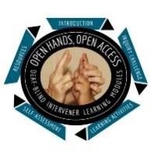
Open Hands, Open Access Deaf-Blind Intervener Learning Modules
Module: Behavior and Environmental Supports

Communication Statements

Instructions
Name:
Date:
Watch this video: Emma & Carolina: Travel from Bus to Classroom
Transcript
- Use the spaces below to make a list of at least 5 possible statements the student might be communicating? (Example: “I’m bored.”)
- Narrow your list down to your top three statements.
- For each of the three statements you think the student may be telling you, describe in detail how you might respond to best:
  - Be understood by Emma
  - Build communication with Emma
  - Provide her an opportunity to behave differently
- Keep the following guidelines in mind as you write your responses:
  - We have choices for how to respond.
  - How we respond is communication to the student.
  - We must be careful to avoid behaving in a way that the student can misinterpret.
  - Our response starts to shape his behavior.
  - His behavior, in response to us, is communication.
List of statements the student may be communicating:
- I’m __________
- I’m___________
- I’m___________
- I’m___________
- I’m___________

- First Possible Statement:
I’m________________

- Second Possible Statement:
I’m ________________

- Third Possible Statement:
I’m _____________

