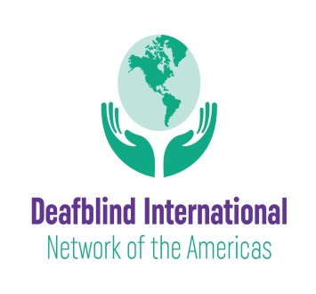 July 17, 2020
Greetings!
We wanted to share exciting news about a newly formed network within Deafblind International—the Network of the Americas. The mission of this network is to provide opportunities and platforms where members can share our successes, challenges and practices toward creating a barrier-free life to people with deafblindness. There are three ways to engage in this network: 1) Become a member of Deafblind International (membership is free); 2) become a member of the Network of the Americas (also free); and 3) if you use Facebook, consider joining our Facebook Group.
Deafblind International, in an effort to remove barriers to participation, has decided to offer free individual memberships. We hope that many members of the national deafblind networks in the United States, Latin America and Canada will join this international organization that offers access to information, their online magazine DbI Review, and regional and international conferences. If you are not yet a member, please register for membership here.
If you would like to become a member of the Network of the Americas and receive future communication, kindly complete our membership form: DbI Network Membership.
The Network of the Americas have convened a very small leadership group for our network to come up with a plan that will provide our members across the United States, Latin America and Canada with an opportunity to learn from one another in a meaningful way. To this end, we want to learn about the needs within our region and connect through a Facebook group, online training and conferences. Our hope is that you will join us and thank you in advance for your interest and support.
We are also happy to share that the Texas School for the Blind and Visually impaired (TSBVI) has enthusiastically become a lead organization in the network who will expand their highly successful Deafblind Symposium as a DbI Network of the Americas activity. This will be a great opportunity for presenters and attendees from the network regions to participate and build relationships with one another. For more information about the 2021 Deafblind Education Symposium and call for presenters, please go to https://www.tsbvi.edu/outreach

With all good wishes during these challenging times.
The Leadership Team of the Deafblind International Network of the America

