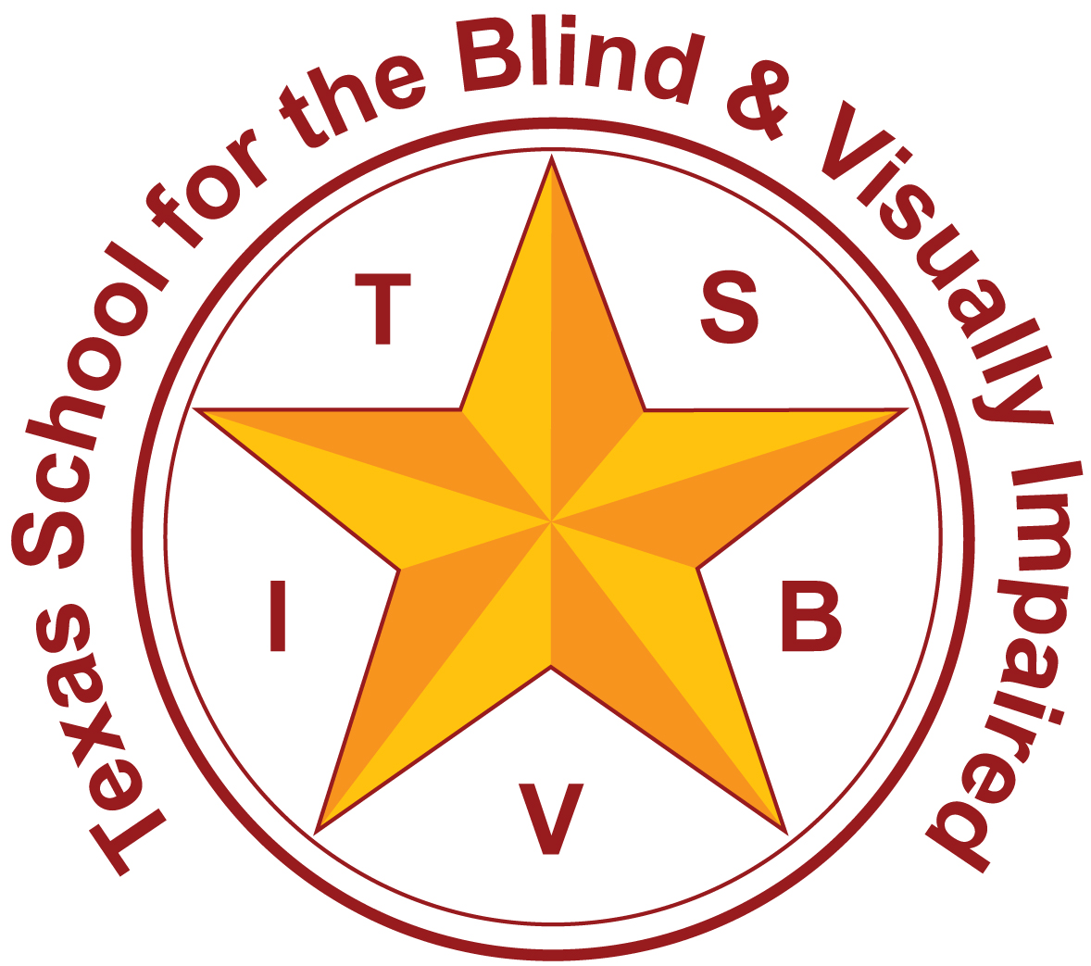 | Texas School for the Blind and Visually Impaired  Outreach Programs  www.tsbvi.edu | 512-454-8631 | 1100 W. 45th St. | Austin, TX 78756

Proficient Communicators with DeafBlindness
IEP Checklist
- Address Requisite Concept (foundational concept) Development through assessment and instruction.

DeafBlindness results in gaps in foundational information that are essential for concept development. Identifying and remediating these gaps is necessary for progress in the general curriculum. Requisite concept development is an area that must be systematically evaluated.

- Modify the curricular content; Develop standards based IEP in core subjects.

For students with DeafBlindness, gathering information takes much longer than typical learners so the pace of instruction should be much slower. Sensory loss limits or prohibits incidental learning throughout the student’s life. This results in the child having significantly less essential background information in comparison to his peers. The scope of the information in a general education classroom can be overwhelming. Modifying the curricular content prioritizes the curriculum so it is both manageable and instructive.

3. Define comprehension check and include an individualized description in the student’s accommodations.

Regular comprehension checks are an important tool in checking for understanding. Many of the academic students with DeafBlindness will reply “Yes” when asked if they understand. Instead of asking students if they understand the material, it is better to ask them if they can explain it.

4. Build time into the day to intervene; add an elective or time in a resource classroom.

Students with DeafBlindness need additional instruction to master essential concepts. They also require instruction in expanded core curriculum for both vision loss and deafness. There is often not adequate time in the current schedule to provide appropriate instruction in these three areas.

5. Apply adaptations and modifications to homework assignments; shorten, provide additional time, allow oral responses. Consider assigning alternative projects, and/or reducing or eliminating homework.

Students with DeafBlindness have to work much harder than their peers to gather information and often experience fatigue. Strategies to reduce or eliminate homework may be necessary for some students. Providing alternative assignments that allow the student to apply knowledge that will help with concept development and understanding.

6. Consider student’s technology needs. Develop a technology plan in the ARD minutes or deliberations.

Students with DeafBlindness often require technology to compensate for the combined vision and hearing loss. They often acquire, and may be responsible for, many more devices than other students in special education.

7. Monitor indications of stress. Consider counseling to support the student with stress management.

Many students with DeafBlindness put forth a great deal of energy and effort over the course of a school day. They have to work harder than their peers to keep up with real time instruction. This can result in extremely high levels of stress as well as feelings of inadequacy and failure.

8. Consider the impact of DeafBlindness on behavioral issues.

For students with DeafBlindness, issues of challenging behavior are usually closely tied to sensory access and communication. Behavior is often the result of coping with situations that seem confusing or threatening due to lack of information available from others or from the environment. It can also be the result of frustration about being ineffective in communicating about important topics in more socially acceptable ways. The student’s difficulty in recognizing, trusting, and bonding with others can have an impact on behavior.

9. Consider the unique social skills needed for a student with DeafBlindness, include these in the IEP and provide direct instruction.

DeafBlindness impacts the ability to form relationships and respond to interactions with others in typical ways. For example, a lack of environmental information makes it difficult to identify people, locate them, know what they are doing, or understand what they want. Many ordinary interactions may seem threatening, negative, or confusing to the student. In turn, the student’s need to gather information by close viewing and/or touch can offend others. It is not unusual to see withdrawal and problems with bonding. It is important to consider that social problems for a student with DeafBlindness are often the result of an on-going lack of essential information.

10. Consider the unique skills needed in self-advocacy for a student with DeafBlindness, include these in the IEP and provide direct instruction.

Being an effective self- advocate about communication and access to information is essential for success in higher education, employment, and other community settings.

11. Consider the unique transition needs of a student with DeafBlindness and include these in the IEP.

As a student enters the teen years and nears graduation, there are considerations for both educational programming and community services. The need for experientially based vocational assessment and instruction in real-world environments is heightened when sensory issues affect access to environmental information and practical experience. Additionally, referrals to community services designed for people with DeafBlindness lead to better adult outcomes (e.g. community intervener, support service provider, interpreter, specialized residential & vocational support).

12. The discussion for supplemental needs and services considers the need for additional resources, training and/or staff to provide in-class support (Intervener, additional interpreter etc)

Certain related services and supports are designed for students with sensory impairments, and should be considered for all students with DeafBlindness. For example, an intervener is a paraprofessional with special skills and training who is designated to work individually with a student who is deafblind. Sign language interpretation and O&M are also examples of specialized services. Additionally, the effects of DeafBlindness should be taken into account in assessments, evaluations and delivery of all related services provided to the student.

