CHARGE Syndrome Foundation, Inc.

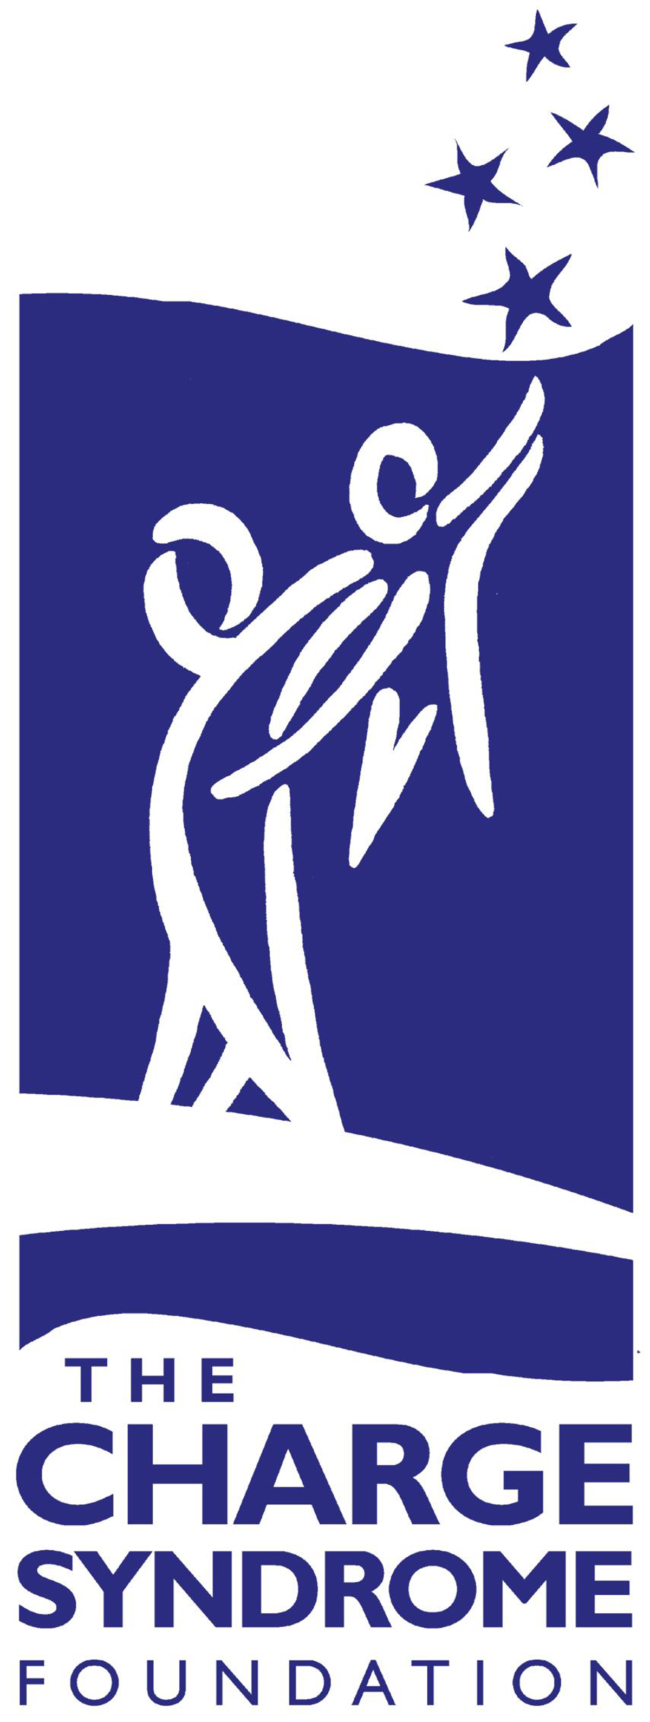

Outreach and Engagement Manager Job Description
Organization and Mission
The Mission of the CHARGE Syndrome Foundation, Inc. is to lead and partner to improve the lives of people with CHARGE syndrome locally, nationally, and internationally through outreach, education, and research.
The CHARGE Syndrome Foundation (CSF) serves individuals with CHARGE, their families, and the professionals that support them. The primary goals of the CSF include growing our outreach and assistance programs; providing resources and materials to our constituents; promoting awareness; building networks and partnerships; and investing in leading-edge research.
The CSF’s signature event is our biennial International Conference. With over 1,200 attendees, including 250 individuals with CHARGE, the conference provides families with resources, education, support, and connection. The CSF also supports regional conferences, webinars, and multiple family assistance programs.
Over the past 10 years, the CSF has awarded over 35 pilot research grants. These grants have launched research into the cause and treatment of CHARGE syndrome.
All of these accomplishments are a result of the hard work and dedication of the volunteers who run the organization.
POSITION SUMMARY
The CSF recognizes that in order to properly serve the growing needs of our community, we need a full time Outreach and Engagement Manager (OEM). The OEM will be responsible for building a supportive and connected community for individuals with CHARGE syndrome, their families, and the professionals that work with individuals with CHARGE.
Initially this position will report directly to the President of the Board of Directors. Over time, the Executive Director will take over the direct supervision of the OEM.
The OEM will work remotely. The position requires some travel to attend conferences and to meet with community stakeholders and partners. The candidate must reside in the United States.
KEY RELATIONSHIPS
As the first full-time OEM for the organization, there are many relationships to foster and grow: individuals with CHARGE and their families, the Board of Directors, Advisors, part-time staff, state liaisons, members, volunteers and partner organizations. The OEM will attend workgroup meetings when appropriate and help support and collaborate with the Family Engagement Workgroup.
The OEM will also communicate with the state deaf-blind projects, other deaf-blind organizations, and rare disease organizations to share resources, ideas and build strong partnerships. The OEM will be the main point of contact for the CSF’s state liaison program.
To successfully navigate these relationships, the chosen candidate will need to build relationships with the CSF’s diverse constituent base. The ideal candidate will also need to increase the CSF’s capacity to guide more individuals with CHARGE and their families through building connections with state deaf-blind projects and other local and national partner organizations.
PRINCIPAL RESPONSIBILITIES
Outreach/Families:
- Create and implement an Outreach Action Plan for the Foundation that aligns with the mission of the Foundation.
- Manage and track measurable results from the Outreach Action Plan.
- Welcome new members, families, and constituents to the CSF.
- Respond to a diverse group of constituents with information and resources to help them navigate the complexities of CHARGE syndrome from a medical, behavioral, developmental, and educational perspective.
- Recruit volunteers to support the CSF’s work and train them to do local, state, and national outreach on behalf of the Foundation.
- Manage the growth and development of the CSF’s State Family Liaison Program.
- Attend our biennial international conference, present on topics relevant to our attendees, and network with professionals, families, and stakeholders.

Collaboration/Partnerships:
- Work collaboratively with the CSF’s board, Executive Director, and workgroups to meet the Foundation’s goals.
- Assess need for, build, and facilitate a network of partner organizations.
- Create collaborative agreements and Memorandums of Understanding (MOUs) between the CSF and partnering organizations for information dissemination, advocacy, and shared outreach to maximize support to families.
- Work with community partners to share and distribute information about programs and services.
Program Development/Communication
- Manage the growth and development of the CSF’s State Family Liaison Program.
- Create and manage electronic content designed for information dissemination and family support.
- Assist in the creation and management of materials designed to inform, educate, and support our families.
- Seek and secure opportunities for grant funding to help support the CSF’s outreach efforts.

QUALIFICATIONS
Required:
- 4 year degree in counseling, social work, special education, public health or related field.
- Experience with and knowledge of supporting individuals with CHARGE or deaf-blindness, and/or their families.
- Understanding of the deaf-blind network and how it operates to support individuals with deaf-blindness and their families.
- Knowledge of and experience with facilitating large and small groups.
- Proficient in the use of online communication methods and digital media to establish and develop relationships.
- Ability to work flexible hours.

Desirable:
- Advanced degree in a related field.
- Training and experience as a provider of direct services to individuals with CHARGE syndrome and/ or deaf-blindness.
- Experience promoting interagency collaboration and networking.
- Knowledge and experience in the delivery of services for individuals with CHARGE syndrome and/or deaf-blindness particularly in the areas of early intervention, early childhood, school age, transition programs, and adult services.
- Skill with creating collaborative agreements/memorandums of understanding.
- Experience with grant writing.
PERSONAL ATTRIBUTES
- Highly motivated and self-directed
- Effective at cultivating and nurturing relationships
- Personal integrity, strong work ethic, problem-solving attitude, and excellent judgment
- High emotional intelligence
- Adept at active listening
- Strong interpersonal and written communication skills
- Ability to present information to small and large groups and communicate effectively to educational and medical providers
- Flexibility and openness to differing opinions and ideas
- Team player, works well in a collaborative environment
- Strong management and decision making skills
- Ability to manage multiple needs/tasks and prioritize time and resources
- Well-developed people, collaboration, and project management skills
- Compassionate and empathetic toward the complex issues our constituent families face
Travel: Ability and willingness to travel domestically
Compensation: Compensation range is $55,000-$75,000 based on experience plus benefit package.
Application Process: To apply for this position submit resume to Outreach@chargesyndrome.org.

The CHARGE Syndrome Foundation is an Equal Opportunity Employer

